**Assignment 1**

By Harsh Sharma

Part 2

**Part II Conceptual Data Modeling**

**Q4.** Read the “**Mountain View Community Hospital**” case study provided.

**Solution:**

|  |  |
| --- | --- |
| **Entity type** | **Description** |
| **Patient** | Individuals admitted to the hospital or registered as outpatients, identified by a medical record number (MRN). |
| **Physician** | Hospital medical staff members who admit patients and administer treatments, identified by a physician ID. |
| Bed | Hospital beds assigned to admitted patients, identified by a bed number and room number. |
| **Nurse** | Healthcare professionals responsible for patient care, identified by an employee number. |
| **Diagnosis** | Medical conditions diagnosed by physicians, identified by a diagnosis ID/code. |
| **Treatment** | Medical tests or procedures ordered and performed for patients, identified by a treatment ID/code. |
| **Order** | Instructions issued by physicians for treatments, tests, or medications, identified by an order ID. |

**(2)** Per each entity types, list all possible attribute types. For attribute characteristics, indicate only composite, complex, multi-valued, derived, and required. If any, indicate the key attribute type(s) of the entity type. Also if available, give other specifications (e.g., domain, constraint) of the attribute type.

Solution:

|  |  |  |  |  |
| --- | --- | --- | --- | --- |
| Entity type | Attribute type | Attribute characteristic  (composite, complex, multi-valued, derived, required) | Key (Simple/Composite) | Other Specification |
| Patient | MRN (Medical Record Number): | Simple, Composite (if composed of multiple parts) | Composite |  |
| Name | Simple, Required | Simple |  |
| Physician | Physician ID | Simple, Required | Simple |  |
|  | Name | Simple, Required | Simple |  |
| Bed | Bed Number | Simple, Required | Simple |  |
|  | Room Number | Simple, Required | Simple |  |
| Nurse | Employee Number | Simple, Required | Simple |  |
|  | Name | Simple, Required | Simple |  |
| Diagnosis | Diagnosis ID/Code | Simple, Required | Simple |  |
|  | Diagnosis Name | Simple, Required | Simple |  |
| Treatment | Treatment ID/Code | Simple, Required | Simple |  |
|  | Treatment Name | Simple, Required | Simple |  |
| Order | Order ID | Simple, Required | Simple |  |
|  | Order Date | Simple, Required | Simple |  |
|  | Order Time | Simple, Required | Simple |  |
|  |  |  |  |  |

**(3)** List all possible relationship types and their degree. List the participation entity types of each relationship type. Also describe the maximum cardinality and maximum cardinality of each relationship type.

Solution:

1. Referral: A patient may be referred to the hospital by exactly one physician. (1 Physician refers many Patients)
2. Admission: A patient must be admitted to the hospital by exactly one physician. (1 Physician admits many Patients)
3. Vital Signs Assessment: Prior to a patient being seen by a physician, a nurse typically obtains and records relevant information about the patient. (1 Nurse assesses vital signs for many Patients)
4. Bed Assignment: A patient may or may not be assigned to a bed. (1 Patient is assigned to 0 or 1 Bed)
5. Diagnosis: Physicians diagnose any number of conditions affecting a patient, and a diagnosis may apply to many patients. (1 Physician diagnoses many Patients, 1 Diagnosis applies to many Patients)
6. Physician's Order: A physician may perform an order for a patient. (1 Physician issues many Orders, 1 Order includes many Treatments)
7. Treatment Performance: A treatment may be performed on any number of patients. (1 Treatment is performed on many Patients)

**(4)** Develop an (E)ER-diagram on the given details of the case study.

Solution:

I’ve hand drawn the EER diagram so I tried with the software, but I wasn’t comfortable with it.

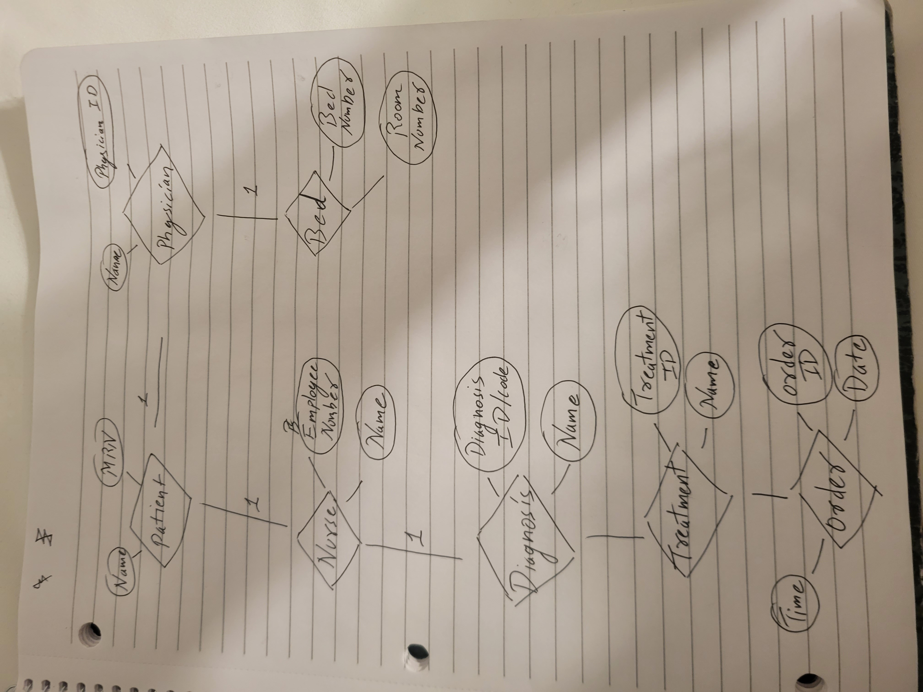

**Q5.** Read the “**Musicmatic**” case study provided.

(1) Develop an (E)ER-diagram on the given details of the case study.

**Solution:**

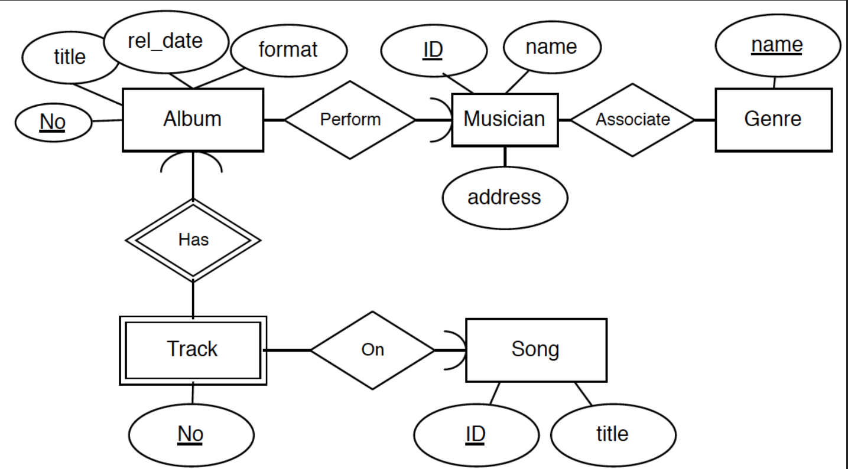

**2)** Present the conceptual database schema of the case study using a UML class diagram.

